Data Mining Assignment 4

1) Read Chapter 4 (all sections) and Chapter 5 (Sections 5.2, 5.5, 5.6 and 5.7).  
  
2) Repeat In Class Exercise #38 using the misclassification error rate instead of information gain to determine the best split. Which of these splits considered is the best according to misclassification error rate?

splitting on A Error(A=T) = 1 - max(4/7, 3/7) = 3/7 = 0.43 Error(A=F) = 1- max(0/3, 3/3) = 0 weighted average error = 7/10 * 0.43 + 3/10 * 0 = 0.30 splitting on B Error(B=T) = 1 - max(3/4, 1/4) = 1/4 = 0.25 Error(B=F) = 1 - max(1/6, 5/6) = 1/6 = 0.16 weighted average error = 4/10 * 0.25 + 6/10 * 0.16 = 0.20 According to misclassification error rate, splitting on B is the best split, because the weighted average error for B is less than A.  
  
  
3) Repeat In Class Exercise #39 using the misclassification error rate instead of information gain to determine the best split. Which of these splits considered is the best according to misclassification error rate?

|  |  |  |  |
| --- | --- | --- | --- |
| A3 | Class label | Split point | Weighted error |
| 1.0 | + | 2.0 | 0.33 |
| 3.0 | - | 3.5 | 0.42 |
| 4.0 | + | 4.5 | 0.33 |
| 5.0 | - | 5.5 | 0.44 |
| 5.0 | + | 5.5 | 0.44 |
| 6.0 | + | 6.5 | 0.44 |
| 7.0 | - | 7.5 | 0.44 |
| 7.0 | + | 7.5 | 0.44 |
|  |  |  |  |

split point 2.0 or 4.5 is the best split according to weighted error.

4) The file <http://www-stat.wharton.upenn.edu/~dmease/rpart_text_example.txt> gives an example of text output for a tree fit using the rpart() function in R from the library rpart. Use this tree to predict the class labels for the 10 observations in the test data <http://www-stat.wharton.upenn.edu/~dmease/test_data.csv> linked here. Do this manually - do not use R or any software.

|  |  |  |  |
| --- | --- | --- | --- |
| Age | Number | Start | Prediction |
| Middle | 5 | 10 | Present |
| Young | 2 | 17 | Absent |
| Old | 10 | 6 | Present |
| Young | 2 | 17 | Absent |
| Old | 4 | 15 | Absent |
| Middle | 5 | 15 | Absent |
| Young | 3 | 13 | Absent |
| Old | 5 | 8 | Present |
| Young | 7 | 9 | Absent |
| Middle | 3 | 13 | Absent |

Predictions on the above test data are:

i. Age = middle, Number = 5, Start = 10 Path : 1 → 2 → 5 → 11 → Present

ii. Age = young, Number = 2, Start = 17 Path : 1 → 2 → 4 → 8 → Absent

iii. Age = old, Number = 10, Start = 6 Path : 1 → 3 → 7 → 15 → Present

iv. Age = young, Number = 2, Start = 17 Path : 1 → 2 → 4 → 8 → Absent

v. Age = old, Number = 4, Start = 15 Path : 1 → 2 → 4 → 8 → Absent

vi. Age = middle, Number = 5, Start = 15 Path : 1 → 2 → 5 → 10 → Absent

vii. Age = young, Number = 3, Start = 13 Path : 1 → 2 → 4 → 9 → Absent

viii. Age = old, Number = 5, Start = 8 Path : 1 → 3 → 7 → 15 → Present

ix. Age = young, Number = 7, Start = 9 Path : 1 → 2 → 4 → 9 → Absent

x. Age = middle, Number = 3, Start = 13 Path : 1 → 2 → 5 → 10 → Absent  
  
5) I split the popular sonar data set into a training set (<http://www-stat.wharton.upenn.edu/~dmease/sonar_train.csv>) and a test set (<http://www-stat.wharton.upenn.edu/~dmease/sonar_test.csv>). Use R to compute the misclassification error rate on the test set when training on the training set for a tree of depth 5 using all the default values except control=rpart.control(minsplit=0,minbucket=0,cp=-1, maxcompete=0, maxsurrogate=0, usesurrogate=0, xval=0,maxdepth=5). Remember that the 61st column is the response and the other 60 columns are the predictors.

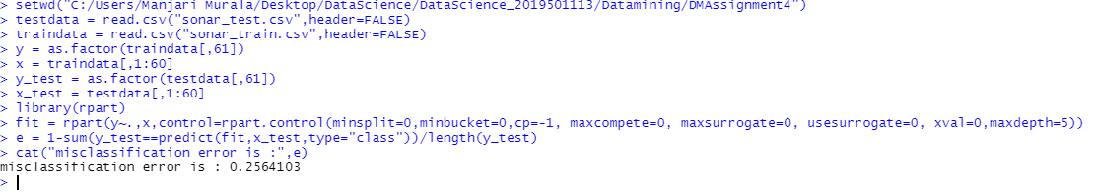  
  
6) Do Chapter 5 textbook problem #17 (parts a and c only) on pages 322-323. Note that there is a typo in part c - it should read "Repeat the analysis for part (b)". We will do part b in class.

You are asked to evaluate the performance of two classification models, M1 and M2. The test set you have chosen contains 26 binary attributes, labeled as A through Z.  
  
7) Compute the misclassification error on the training data for the Random Forest classifier from In Class Exercise #47. Show your R code for doing this.

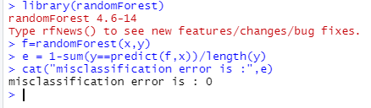  
  
8) This question deals with In Class Exercise #42.  
  
a) Repeat In Class Exercise #42 for the k-nearest neighbor classifier for k=5 and k=6.  
  
b) Repeat part a using the exact same R code a few times. Explain why both the training errors and the test errors often change for k=6 but not for k=5. Hint: Read the help on the knn function if you do not know.

